Ross Alexander
May 15th 2020
TRR’s Simulation With a Custom Map Instructions
The purpose for this document is to serve as an instruction manual for generating an optimum path though a mapped environment using TRR’s simulation software. The software presented in this document is split into two categories.

1. Mapping software: use a D435i depth camera to create a point cloud map of an environment.

2. Planning software: use the HKUST Areal Robotics Groups simulator associated with their Teach Repeat Replan paper to identify the optimum path though your mapped environment.

Notable Software Files (Mapping Software)
- /home/ralexander/Github/TRR_With_Custom_Map.sh
  - .sh file that includes all the terminal commands and instructions for running the software for this project
- /home/ralexander/Github/catkin_ws_r/src/rs4se/launch/rs4se.launch
  - The launch file for the custom camera driver rs4se created by Shuxiao Chen (Shu)
  - No values were modified within this file
- /home/ralexander/Github/catkin_ws_r/src/VINS-Mono/config/euroc/euroc_config.yaml
  - The configuration yaml file for Vins-MONO within which you specify the camera extrinsic parameters and topics you want Vins-MONO to use to locate your camera.
    - imu_topic: "/rs/imu0/data" IMU topic from rs4se
    - image_topic: "/rs/ir0/image" Image topic from rs4se
    - td: 0.007 Time offset between the Image and IMU Clock
- /home/ralexander/Github/catkin_ws_r/src/VINS-Mono/vins_estimator/launch/euroc.launch
  - This is the .launch file for Vins-MONO
    - Tells the program to use the euroc_config.yaml file above
- /home/ralexander/Github/catkin_ws_r/src/VINS-Mono/vins_estimator/launch/vins_rviz.launch
  - This is the .launch file for rviz that will show you the output from Vins-MONO. Just sends you to a rviz configuration file.
- /home/ralexander/Github/catkin_ws_a/src/ground_station/mapping.sh
  - this is the .sh file that uses Surfel Fusion to generate a point cloud map using the output of Vins_Mono
- /home/ralexander/Github/catkin_ws_a/src/ground_station/global_mapping/surfel_fusion/launch/global_map_fusion.launch
  - This is the launch file for Surfel Fusion where you specify the camera pose, image, and depth image ROStopics
    - <remap from="~image" to="/rs/ir0/image" /> This image topic needs to be the same as in the euroc_config.yaml file
    - <remap from="~depth" to="/rs/depth0/image" /> This is the depth image topic from rs4se

Notable Software Files (Planning Software)
- /home/ralexander/Github/TRR_With_Custom_Map.shRR_With_Custom_Map.sh
  - .sh file that includes all the terminal commands and instructions for running the software for this project
- /home/ralexander/Github/catkin_ws_trr/src/Teach-Repeat-Replan/trr_simulation.sh
  - .sh file that runs TRR’s simulator
- /home/ralexander/Github/catkin_ws_trr/src/Teach-Repeat-Replan/simulation/cascade_control/launch/simulator.launch
  - .launch file for the quad-copter simulator, use this to change the initial position of the simulated drone
    - <param name="simulator/init_state_x" value="-3.5"/>
    - <param name="simulator/init_state_y" value="-3.5"/>
    - <param name="simulator/init_state_z" value=" 0.5"/>
- /home/ralexander/Github/catkin_ws_trr/src/Teach-Repeat-Replan/global_planner/launch/map_generator.launch
  - .launch file for TRR’s random map generator, currently this map is not used, but you can use it to generate an obstacle field of your choosing my modifying parameters and ROS bagging the output.
    - <param name="map/circle_num" value="50"/>
    - <param name="map/obs_num" value="100"/>
    - <arg name="map_size_x" default="20.0"/>
    - <arg name="map_size_y" default="20.0"/>
    - <arg name="map_size_z" default=" 3.0"/>
- /home/ralexander/Github/catkin_ws_trr/src/Teach-Repeat-Replan/global_planner/launch/global_planner.launch
  - .launch file for the global planner node, this allows you to control the size of the polyhedrons in TRR’s simulator. Why is this important? Recall that TRR generates an optimum path through the polyhedron array, therefore the size and shape and height of the polyhedrons drastically affects the optimum path.
  - Example: If the polyhedrons are too high, your optimum path will fly over the top of your map instead of through it
    - map_size_[xyz]
      - Size of the area that polyhedrons are allowed to be generated.
      - Example: You map a 4x4x2 obstacle, and here your map_size is 5x5x2. In the simulator the polyhedrons will be 2 units high and only extend 1 unit from the outer edge of the obstacle to a position 5 units away from the origin.
      - <arg name="map_size_x" default="10.0"/>
      - <arg name="map_size_y" default="10.0"/>
      - <arg name="map_size_z" default="2"/>
    - max_vel
      - Max velocity of the drone
    - max_acc
      - Max acceleration of the drone
    - poly_order
      - Polynomial order of the optimum trajectory
    - planning/max_d_acc
      - Max rate of change of acceleration
- /home/ralexander/Github/catkin_ws_trr/src/Teach-Repeat-Replan/local_replanner/local_replanner/launch/local_replanner.launch
  - .launch file for the local re-planner
    - map_size_[xyz]
      - Area the local re planner will consider “legal” for creating re-planned trajectories.
    - poly_order
    - max_vel
    - max_acc
- /home/ralexander/Github/catkin_ws_a/src/ground_station/teaching_planning.sh
  - .sh file that creates in inflated map
- /home/ralexander/Github/catkin_ws_a/src/ground_station/global_planner/launch/global_planner_exp.launch
  - .launch file that sets up the nodes that make the inflated map
- /home/ralexander/Github/catkin_ws_a/src/ground_station/global_planner/src/teach_repeat_planner.cpp
  - .cpp file that houses the algorithm for the inflated map

Installation Procedure
Install all dependencies and get the following programs to run on your computer
- Teach Repeat Re-plan Main Branch https://github.com/HKUST-Aerial-Robotics/Teach-Repeat-Replan
- VINS-Mono https://github.com/HKUST-Aerial-Robotics/VINS-Mono

Mapping an Environment
In this section the process for mapping out an environment is described so that a user can create a point cloud map of an environment he/she wants to optimize a path thorough. Note, I highly recommend that if you are new to this you go this process once with Shu.

Inside the TRR_With_Custom_Map.sh file you will see the commands to execute mapping. During this process you will
- Start the camera driver rs4se
- Start VINS-Mono to obtain an estimate of the cameras current position and orientation
- Use Rviz to check the state estimate obtained by VINS-Mono
- After closeing Rviz, start Surfel-Fusion to build a point cloud by combining the depth image from rs4se and the cameras state from VINS-Mono

Step 1, Plug in the camera: Intel D435i Depth Camera
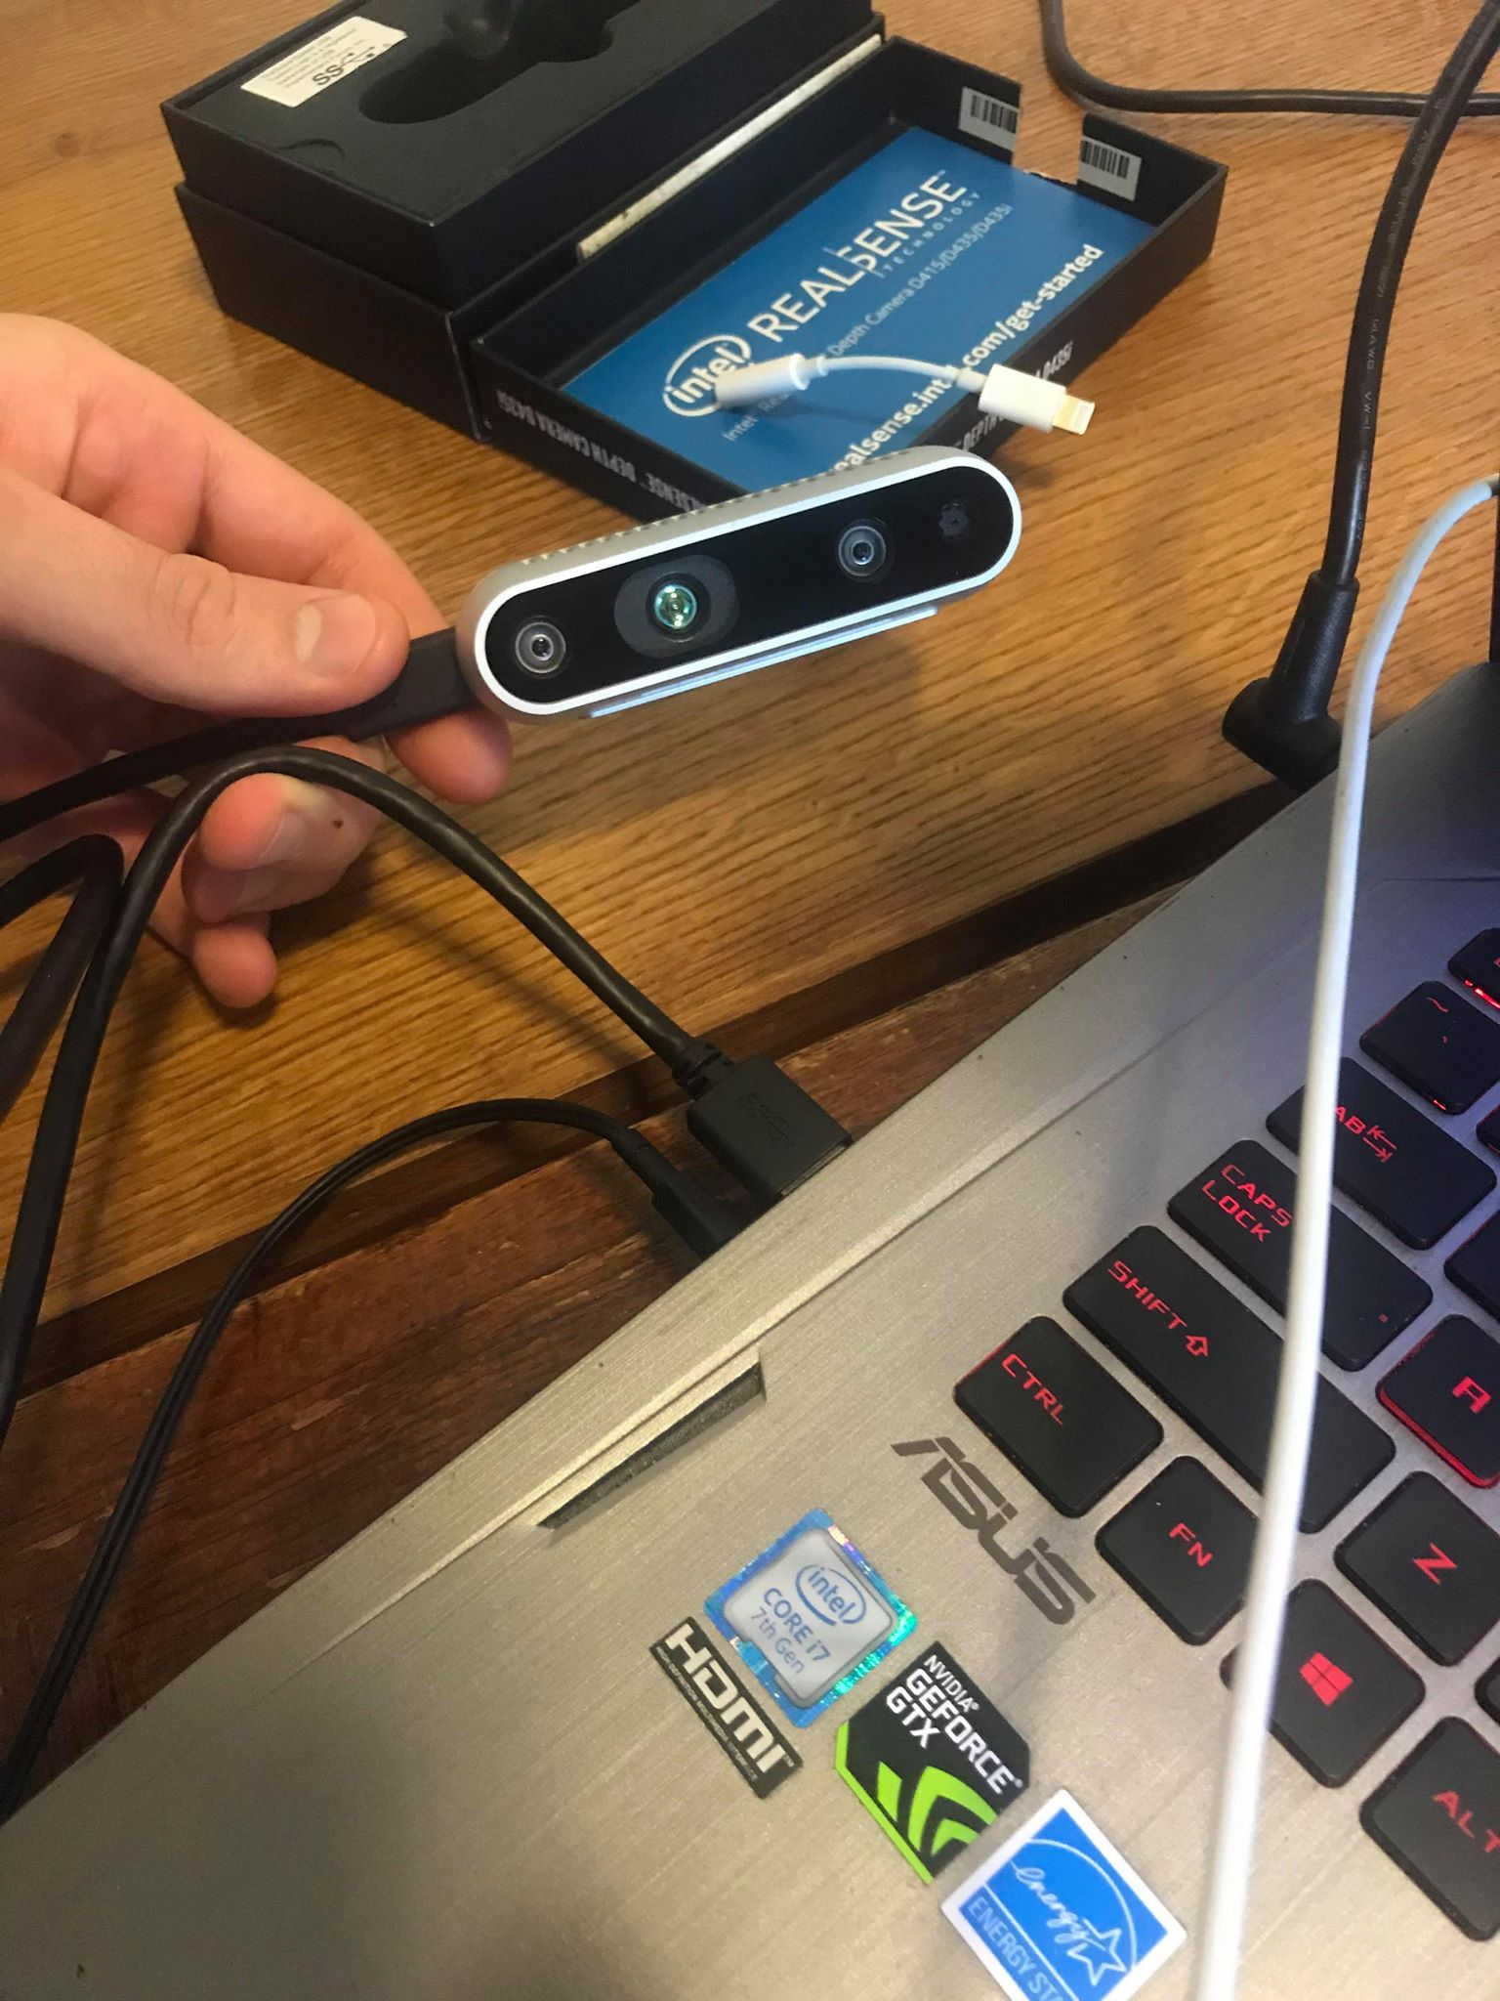

Step 2, Follow Along in this video https://drive.google.com/open?id=1mOaSCpTJieUQ3cFGDOCdT7mwziT2xOgW

Path Optimization
This section describes the process for importing the point cloud map into TRR’s simulator and describes how to generate an optimal path though the environment from a teaching trajectory. Additionally, the parameters that effect the optimum path are described along with their effect.

Inside the TRR_With_Custom_Map.sh file you will see the commands to execute planning. During this process you will
- Start roscore
- Create a point cloud ROStopic from a .pcd file
- Use key2joy to create a controller interface on your keyboard
- Run a modified version of the HKUST Areal Robotics Groups TRR project that uses the custom map you created earlier.
  - Note, you will need to move the .pcd file you generated in the mapping phase to the file location specified in the rosrun pcl_ros pcd_to_pointcloud command

Follow Along in this video https://drive.google.com/open?id=1zMSyWv-TfmQJRrOvJVQmEUx24sPxNPSg

Notable ROS Topics
/cloud_pcd > Point cloud map of environment
/odom_visualization_1/path > Teaching Trajectory
/odom_visualization_1/robot > Simulated drones position
/tr_node/polyhedron_corridor_mesh > polyhedron array
/tr_node/trajectory_vis > Optimal Trajectories
/local_replanner/replaned_b_spline_vis > Replaned Trajectory

